TITLE PLACED HERE & AT A MAXIMUM OF 150 CHARACTERS INCLUDING SPACES: TITLE PLACED HERE TITLE PLACED HERE TITLE PLACED HERE TITLE PLACED HERE TITLE

Author Name 1  Institution  Institution 2  Country  ORCID | Author Name 2  Institution  Institution 2  Country  ORCID

Abstract: Text to be 120-150 words. Text to be 120-150 words. Text to be 120-150 words. Text to be 120-150 words. Text to be 120-150 words. Text to be 120-150 words. Text to be 120-150 words. Text to be 120-150 words. Text to be 120-150 words. Text to be 120-150 words. Text to be 120-150 words. Text to be 120-150 words. Text to be 120-150 words. Text to be 120-150 words. Text to be 120-150 words. Text to be 120-150 words. Text to be 120-150 words. Text to be 120-150 words. Text to be 120-150 words. Text to be 120-150 words. Text to be 120-150 words. Text to be 120-150 words. Text to be 120-150 words. Text to be 120-150 words. Text to be 120-150 words. Text to be 120-150 words. Text to be 120-150 words. Text to be 120-150 words.to be 120-150 words. Text to be 120-150 words.

Keywords: four to six, on average, key words or key phrases.

©2024 Author Name, Author Name, Author Name & Author Name, and the Centre of Sociological Research, Poland
DOI: https://doi.org/10.14254/1795-6889.2024.20-1.1

This work is licensed under a Creative Commons Attribution-NonCommercial 4.0 International License.
INTRODUCTION [and sections are not numbered]

Text here with first line of paragraph flush left. All text in the paper body should be black Times New Roman, 12 pts, and fully justified. The red text is just explanatory information.
The second paragraph is indented .75 cm. The Introduction presents the specific research problem that was under study and the research strategy taken to meet the study goals. This chapter (and, if necessary subsections and additional chapters) should describe why the study is important, the gap in the literature that the study aims to fill, how the employed research design is related to the identified research problem, and how the current study relates to prior research in the literature. For quantitative studies, researchers typically present what theoretical propositions were tested and how were they derived.
Also the Introduction should present clearly the synthesized literature that grounds the current research, including what is needed for the reader who is not a specialist to understand the problem at hand (but not an exhaustive review), and significant earlier works related to the topic, particularly important methods, findings, or conclusions. The review should be logical, fair, and balanced, allowing the reader to see clearly the connection and gaps within the research literature and between that prior research and the current research topic.
The third major component of the Introduction is the research purpose, an explanation of how the research was designed to solve the research problem. This would include what hypotheses or research questions guided the research project and any expectations the researcher had regarding the study, with supporting rationale and literature.
A few points are offered here regarding writing in APA style, although the author should consult the APA manual explicitly for recommendations on how to write clearly, precisely, and with a good flow for the reader. Stylistically, follow the APA manual regarding special formatting (i.e., use of italics, quotation marks, and capitalization), which are used sparingly and for specific purposes. Use lowercase letters for in-text seriation (enclosed in paretheses); numbers are reserved for seriated paragraphs. Consult the Merriam-Webster’s Collegiate Dictionary as a guide for capitalization, spelling, and/or need for italics related to foreign words. (Setting the language option on your paper to US English will help improve the language usage, as Word will flag nonstandard usages for your inspection.) The APA provides a list of common prefixes that typically are not hyphenated; follow that list and the exceptions. The APA style also includes use of the serial comma in lists of three or more. Please provide all citations in APA style.
Human Technology also has a few specific stylistic requirements. Each paragraph must include a minimum of two sentences. Avoid situations in which single words (or two short words) are alone on a line at the end of a paragraph or a single sentence is at the start of a new page. And, whenever possible, avoid multiple subsequent lines that end with hyphenated words. (Sometimes adjusting letter spacing can help avoid these two issues.) When referring specifically to published research, use past-tense verbs. Remove all extra spaces between words and sentences should be separated with just a single space. Do not add needless hard returns or extra paragraph formatting. Papers should be single-spaced.
This journal’s editors also recommend that authors be attentive to an over-reliance on the verb to be (is/are, has/have, including the there is/there are constructs). In English, compelling and precise writing is based on strong verbs. Whenever possible, and it is not always possible, reword to use the stronger verb. The same applies to (a) splitting a verb with an adverb, particularly when the meaning does not change by placing the adverb before or after the compound verb; and (b) using active voice whenever possible. Although passive voice does serve a valid purpose in academic writing, active voice is more direct and compelling writing. Also, do not use contractions in academic writing. Finally, avoid the following issues: anthropomorphisms and the “editorial we.” Anthropomorphisms happen when the wording provides agency to an inanimate item. So, for example, an article does not analyze a phenomenon; rather, the researchers analyze within the article. The editorial we exists when the authors use first-person pronouns to apply to a group other than themselves. The concern is that the reader does not know to whom exactly that pronoun refers. Thus, in a sentence that says, “The data helps us see how our views can change with explicit intervention,” the reader cannot know if the authors mean themselves or society or users in general or what. Thus, the authors should reserve first-person pronouns to refer only to themselves (i.e., do not refer to themselves in third person) and revise the text to something akin to, “The data helps users see how their views can change….” Again, the APA Manual provides additional information on various writing practices.
Finally, all papers are to be written in good English. Whether a native speaker or not, be sure to use appropriate tenses, noun−verb agreement, appropriate punctuation, and so on. If the authors cannot manage this task, a skilled English-language editor who is familiar with the APA style should be engaged to proof the language. The APA style of English, word use, and punctuation (and its recommended guides for areas the APA does not address explicitly—e.g., the Merriam-Webster’s dictionary and the Chicago Manual of Style) are the only resources for the English language usage in papers accepted for publication in Human Technology. Some aspects of all of these resources are available online. Additional information is available on Human Technology’s Web site.

Subheadings Have Major Words Capitalized

Text here with first line of paragraph flush left. Tables and figures are to be mentioned in the text prior to their placement in the paper. Typically, tables and figures are placed at the top or bottom of the page as soon as possible as their introduction (see Table 1); text, then, is wrapped around. Please note that the exact placement of any table or figure will be determined during the layout process once a paper is accepted. An example of a table is presented here; other examples of tables and figures are included below for information. Please note that all tables need to be titled appropriately (with all major words capitalized, placed above the table) and all figures with a sufficiently clear caption (with only the first word, first word after a colon, or proper nouns capitalized, placed below the figure). Tables and figures should be prepared in the font Arial, 8−11 points. (If a different size is needed, that can be discussed with the journal’s managing editor if the paper is accepted.)
The second paragraph is indented .75 cm. The APA stipulates that tables and figures should be included in a paper only if they provide additional essential information that cannot be provided within the text or explained clearly enough by way of text. Moreover, all tables and figures should be presented in a way that allows them to “stand alone,” meaning that any reader can understand what is being communicated even if he/she has not read the entire paper. Tables and figures should be created as close to final style as possible (i.e., fit within the templates margins), although changes may need to be made following review by the editors).
Table 1. Characteristics of the Multimodality Fusion Types (Iovane et al., 2012). [Source: García-Betances, Fico, Salvi, Ottaviano, & Arrendondo, 2015. Table titles have major words capitalized.]
Type | Characteristics
Data fusion | Performed on each signal’s raw data  Applied only when the signals have the same temporal resolution  Not commonly used because of its sensitivity to noise
Feature fusion | Performed on the set of features extracted from each signal  (e.g., statistical measurements and other unique features from each sensor)  Used in multimodal user interfaces and in AC
Decision fusion | Performed by merging the output of the classifier for each signal  Most commonly used approach for multimodal HCI

If color is used in a table or figure, please assure that the color value differences are apparent even if the paper is printed in black and white. More information on tables and figures is available in the APA manual.
Text and more text. This continues as needed. Second paragraph is indented .75 cm. Text and more text. This continues as needed. More text. This continues as needed. Second paragraph is indented .75 cm. Text and more text. Text, text, and more text. Text, text, and more text. Text, text, and more text. Text, text, and more text. Text, text, and more text. Text, text, and more This continues as needed. Second paragraph is indented .75 cm. Text and more text. This continues as needed. Second paragraph is indented .75 cm. Text and more text. This continues as needed.
Text, text, and more text. Text, text, and more text. Text, text, and more text. Text, text, and more text, and and additional text. Text, text, and more text. Second paragraph is indented .75 cm. Text, text, and more text. Text, text, and more text. Text, text, and more text. Text, text, and more text. Text, text, and text. Second paragraph is indented .75 cm. Text, text, and more and more text. Text, text, and more text. Text, text, and more text. Text, text, and more text. Text, text, and more text. Text, text, and more text. Text, text, and more text. Text, text, and more text. Text, text, and more text. Text, text, and more text. Text, text, and more text. Second paragraph is indented .75 cm. Text, and additional text, and more text. Text, text, and more text. Text, more text, and more text. Text, text, and more text. Text, text, and more text. Text, text, and continuing text. Text, text, and more text. Second paragraph is indented .75 cm. Text, text, and more text. Text, text, and more text. Text, text, and more text. Text, text, and more text. Second paragraph is indented .75 cm. Text, text, and more text. Text, text, and more text. Text, text, and more text. Text, text, and more text. Text, text, and more text.

Chapters Must Have Two or More Subheadings or None

Text here with first line of paragraph flush left. Text here with first line of paragraph flush left. More text here. Text here with first line of paragraph flush left. Text here with first line of paragraph flush left. Text here with first line of paragraph flush left.
Second paragraph is indented .75 cm. Text and more text. This continues as needed. Second paragraph is indented .75 cm. Text and more text. This continues as needed. Second paragraph is indented .75 cm. More text. This continues as needed. Second paragraph is indented .75 cm. Text and more text. This continues as needed. Second paragraph is indented .75 cm. Text and more text. This continues as needed. Second paragraph is indented .75 cm. Text and more text. This continues as needed.

The Third Level Headings are not Bold and Indented 1 cm or .5 inches

Text here with first line of paragraph flush left. Text here with first line of paragraph flush left. More text here. Text here with first line of paragraph flush left. Text here with first line of paragraph flush left. Text here with first line of paragraph flush left.
Subsequent paragraphs also are indented .75 cm. Text and more text. This continues as needed. Subsequent paragraphs also are indented .75 cm. Text and more text. This continues as needed. Subsequent paragraphs also are indented .75 cm. Text and more text. This continues as needed. Subsequent paragraphs also are indented .75 cm. Text and more text. This continues as needed. Subsequent paragraphs also are indented .75 cm. Text and more text. This continues as needed.
Second paragraph is indented .75 cm. Text and more text. This continues as needed. Second paragraph is indented .75 cm. Text and more text. This continues as needed. Second paragraph is indented .75 cm. More text. This continues as needed. Additional text as needed. Second paragraph is indented .75 cm. Text and more text. This continues as needed. Subsequent paragraphs are indented .75 cm. This continues as needed. Subsequent paragraphs are indented .75 cm. Text and more text. This continues as needed.
Text, text, and more text. Subsequent paragraphs are indented .75 cm. Text, text, and more text. Text, text, and more text. Text, text, and more text, and additional text. Subsequent paragraphs are indented .75 cm. Text, text, and more text. Subsequent paragraphs are indented .75 cm. Text, text, and more text. Text, text, and more text. Text, text, and more text. Subsequent paragraphs are indented .75 cm. Text, text, and more text. Subsequent paragraphs are indented. Text, text, and text. Text, text, and more and more text. Text, text, and more text. Text, text, and more text. Text, text, and more text. Text, text, and more text. Subsequent paragraphs are indented .75 cm. Text, text, and more text. Subsequent paragraphs are indented .75 cm. Text, text, and more text. Text, text, and more text. Text, text, and more text. Text, text, and more text. Text, text, and more text. Subsequent paragraphs are indented .75 cm. Text, and additional text, and more text. Subsequent paragraphs are indented .75 cm. Text, text, and more text. Text, more text, and more text. Text, text, and more text. Text, text, and more text. Text, text, and continuing text. Text, text, and more text. Subsequent paragraphs are indented .75 cm. Text, text, and more text. Subsequent paragraphs are indented .75 cm. Text, text, and more text. Text, text, and more text. Text, text, and more text. Text, text, and more text. Subsequent paragraphs are.75 cm. Text, text, and more text. Text, text, and more text. Text, text, and more text. Text, text, and more text.
Second paragraph is indented .75 cm. Text and more text. This continues as needed. Second paragraph is indented .75 cm. Text and more text. This continues as needed. Second paragraph is indented .75 cm. More text. This continues as needed.

As Before, Two Third-Level Headings Per Section or None

Text here with first line of paragraph flush left. Please note that the subheading here has more than the single line spacing separating it from the previous paragraph, as is the typical layout. That is because headings should have either a minimum of two lines of text under the subhead before continuing on the next page or the heading itself is moved to the next page.
Subsequent paragraphs also are indented .75 cm. Text and more text. This continues as needed. Subsequent paragraphs also are indented .75 cm. Text and more text. This continues as needed. Subsequent paragraphs also are indented .75 cm. Text and more text. This continues as needed. Subsequent paragraphs also are indented .75 cm. Text and more text. This continues as needed. Subsequent paragraphs also are indented .75 cm. Text and more text. This continues as needed. Please note that line returns (in Times New Roman, 12 pt.) separate the text from the end of one paragraph to the next major heading.)

METHODS

Text here with first line of paragraph flush left. In all empirical studies and many non-empirical papers, a Methods section is needed to assist the reader in understanding what was done in the research project and why. Particularly for empirical studies, the information should be complete enough for a reader to recreate the study design and achieve significantly similar results, should that be desired. The Methods section also allows the reader to assess the appropriateness of the methods and the validity and reliability of the study’s results.
Second paragraph is indented .75 cm. For the readers’ benefit, authors should provide specific information regarding the participants or informants, the apparatus or materials used to gather the data, an explication of the data collection procedure, and the data analysis process. (Please note that authors can place this last item, the data analysis process, at the start of the Results section, as is typical for many quantitative empirical studies.)
Authors can distribute this information into focused, titled subsections if appropriate for the research reporting. Provide all essential information on the study process so the reader has sufficient understanding and is not burdened by confusion or questions. Moreover, if ethical approval was obtained from on oversight organization prior to data collection, that information should be made explicit in this section (but not necessarily as a subsection unless the process was atypically complicated).
Subsequent paragraphs also are indented .75 cm. A few more points are provided here for consideration. If a survey instrument was employed in the data gathering, this needs to be explained fully in the Methods section. The actual instrument can be provided, if desired, as an appendix to the paper. If the study was completed in a language other than English (or if non-native speakers of English are participating in an English-language study), please provide information regarding the participants’ linguistic competence in the language of data collection and how any data presented in the research report was translated. This is particularly important for qualitative studies that provide data quotations in their Results section to support their findings.
The APA manual provides extensive information regarding the various sections within the Methods. Table 2 is an example of information supporting data collection; taken from Mazambani, Carlson, Reysen, & Hemelmann, 2015).
Text and more text. This continues as needed. Subsequent paragraphs are indented .75 cm. Text and more text. This continues as needed. Second paragraph is indented .75 cm. More text. This continues as needed. Second paragraph is indented .75 cm. Text and more text. This continues as needed. Second paragraph is indented .75 cm. Text and more text.
Subsequent paragraphs also are indented .75 cm. Text and more text. This continues as needed. Subsequent paragraphs also are indented .75 cm. Text and more text. This continues as needed. Subsequent paragraphs also are indented .75 cm. Text and more text. This continues as needed. Subsequent paragraphs also are indented .75 cm. Text and more text. This continues as needed. This continues as needed. Subsequent paragraphs also are indented .75 cm. Text and more text. This continues as needed.
Subsequent paragraphs also are indented .75 cm. Text and more text. This continues as needed. Subsequent paragraphs also are indented .75 cm. Text and more text. This continues as needed. Subsequent paragraphs also are indented .75 cm. Text and more text. This continues as needed. Subsequent paragraphs also are indented .75 cm. Text and more text. This continues as needed. Subsequent paragraphs also are indented .75 cm. Text and more text. This continues as needed.

Table 2. Example of a Table.
 | Complete Forum Data (collected from beginning of forum to February 21, 2014) |  |  |  | Analysis Period Data  (collected from  January 1, 2010‒February 21, 2014)
Forum | All Users | Threads | Posts |  | Active Users | Analyzed threads | Analyzed posts | Posts containing a meme
Entertainment
trekbbs.com | 24,427 | 11,931 | 903,152 |  | 6,792 | 11,742 | 715,056 | 8,158
advrider.com | 69,058 | 58,745 | 2,740,588 |  | 67,577 | 37,311 | 2,005,278 | 19,797
Political
straightdope.com | 9,940 | 13,941 | 746,305 |  | 9,923 | 13,382 | 85,697 | 47,834
defensivecarry.com | 26,522 | 62,473 | 1,607,552 |  | 26,519 | 37,183 | 944,902 | 15,517
Total | 129,947 | 147,090 | 5,997,597 |  | 117,603 | 99,618 | 3,750,933 | 91,306
Note. Please note that tables and figures are placed at the top and bottom of pages, whenever possible. Exceptions are made for tables and figures if they are to appear before the immediate start of a major section, such as this example. This formatting, by the way, other than the color, is how an author would provide a table note, if needed.]

RESULTS

Text here with first line of paragraph flush left. This section summarizes the data collected and any statistical or data analysis processes that were not defined in the Methods. The data presented should be complete (even if hypotheses are not corroborated). Discussion of the implications of the results would not be included in this section. Consult the APA manual regarding additional information related to tables and figures. Figures 1 and 2 are examples of the types of figures. Figure 3 (Halkosaari, Sarjakoski, Ylirisku, & Sarjakoski, 2013), Figure 4 (Matheus & Svigliato, 2015), and Figure 5 (O’Neill & Benyon, 2015) are additional examples. Table 3 (Matheus & Svigliato, 2015) is a table example of results.
Second paragraph is indented .75 cm. Text and more text. This continues as needed. Second paragraph is indented .75 cm. Text and more text. Additional text can be added. Text and more text. This continues as needed. Second paragraph is indented .75 cm. Text and more text. Additional text can be added. Supplemental text can be used. This continues as needed. Text and more text. Additional text can be added. ext and more text. This continues as needed. Second paragraph is indented .75 cm. Text and more text. Additional text can be added as needed. Text and more text. This continues as needed. Second paragraph is indented .75 cm. Text and more text. Additional text can be added. Supplemental text can be used. This continues as needed. Text and more text. Additional text can be added.

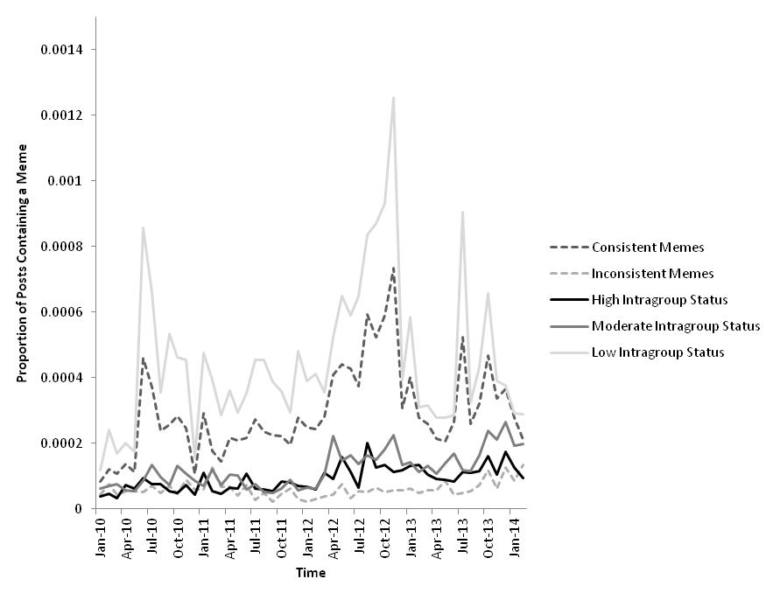
Figure 1. Proportion of posts containing a meme, for each group: consistent and inconsistent meme,
and high vs. moderate vs. low intragroup status (see pp. 153-154 for an explanation of intragroup status). Values on the y-axis equal total number of posts containing a meme divided by total number of posts. Consistent memes agree with the content of the forum; inconsistent memes disagree with forum content. [Source: Mazambani et al., 2015]

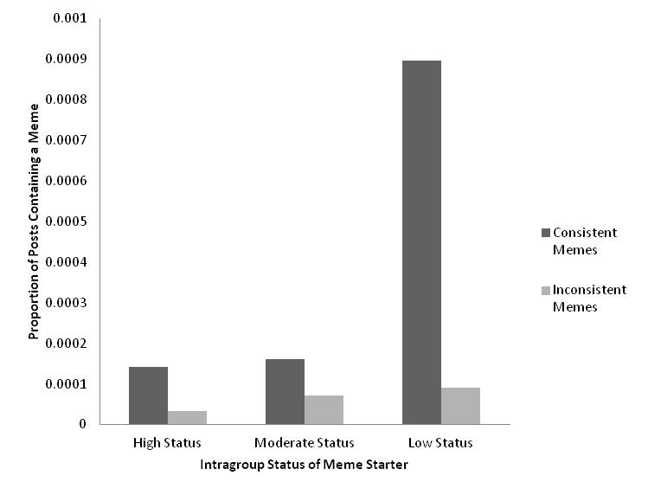
Figure 2. Interaction between meme consistency and intragroup status of the person
who started the meme.
[Source: Mazambani et al., 2015]

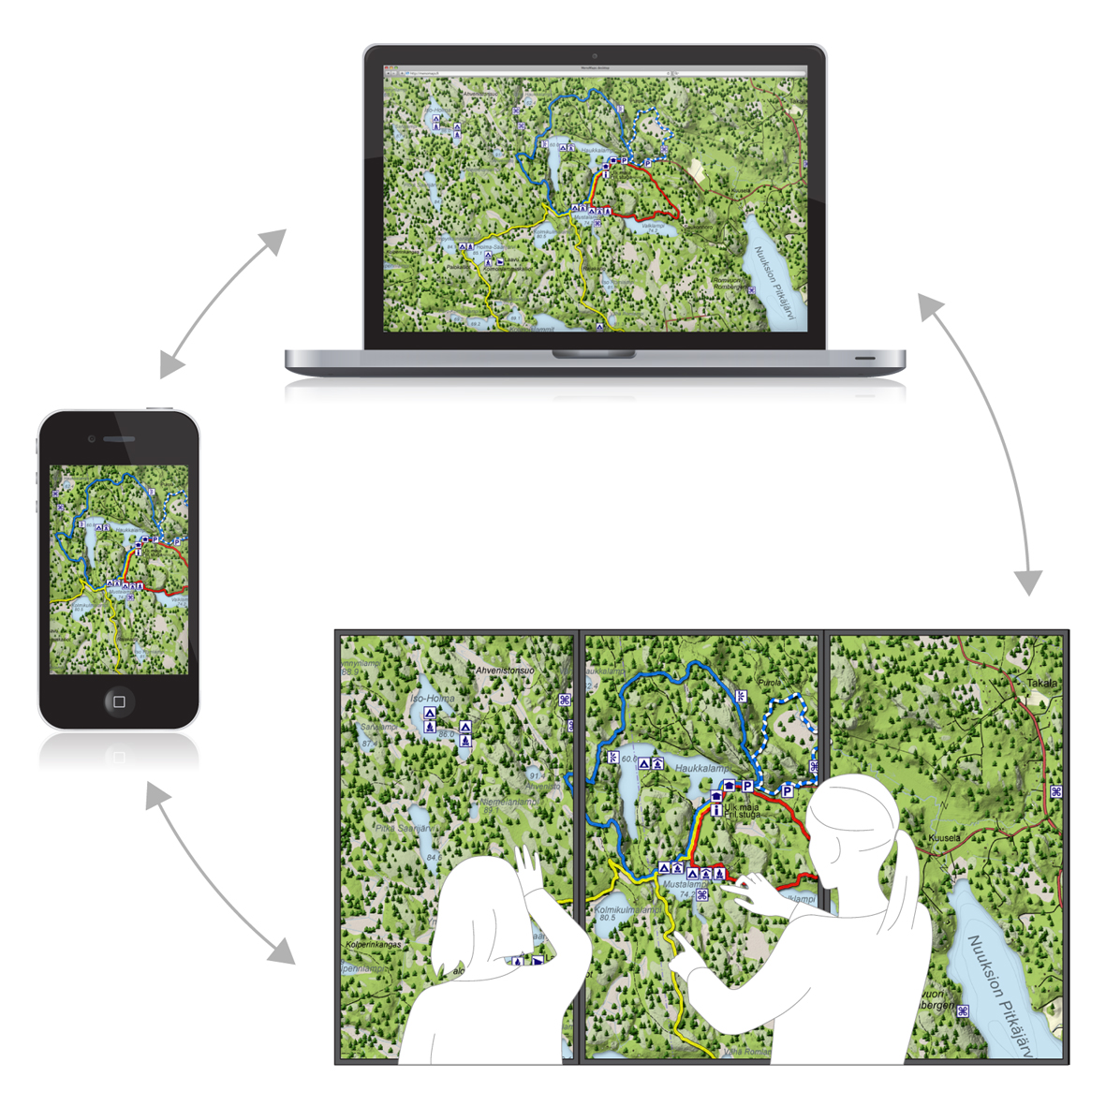
Figure 3. The three interactive channels (a mobile map, a Web map, and a map on a large multitouch screen) of a multichannel map service. [Source: Halkosaari, Sarjakoski, Ylirisku, & Sarjakoski, 2013]
Test Selection Page Participant selects a test and enters password

Informed Consent Page Participant reads informed consent and presses Next to agree and proceed

Introduction Page Participant can optionally be assigned to experimental and control groups

Test Page Participant reads the test instructions and completes the test

Primer Page Participant is introduced to instructions for experimental and control groups

External Website Participant can be optionally redirected to an external Website
Confirmation Page Participant is informed that testing is complete

Figure 4. Flow of the OpenSR process from participant’s experience. Solid lines ( ) represent mandatory testing path process. Dotted lines ( ) represent optional testing path process that
can be specified by researchers during test configuration in the administrative dashboard.
[From Matheus & Svigliato, 2015]

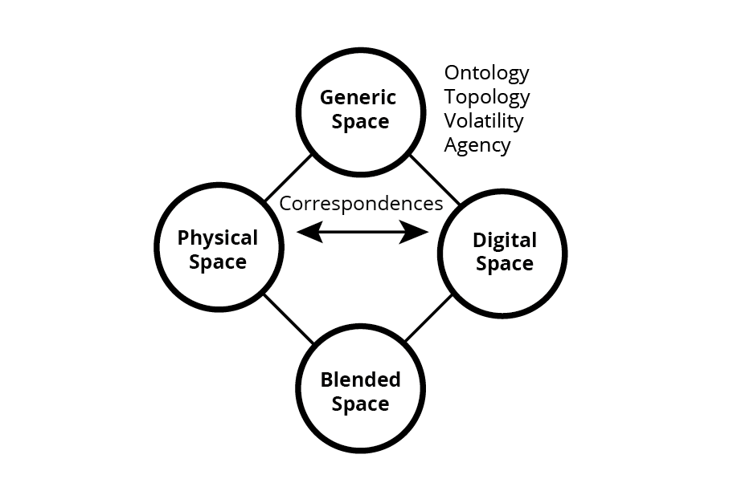
Figure 5. Conceptual blending in mixed-reality spaces. [Source: O’Neill & Benyon, 2015]

Table 3. Software for Stimulus–Response Experiments. [Source: Matheus & Svegliato, 2015]
Software | License | Operating System | GUI | Browser Based | Stimuli Options | Input/Output Options
Affect 4.0 | Open | W | ✓ | X | I, A | K, Mo
DirectRT | Proprietary | W | ✓ | X | T, I, A, V | K, Mo, Mi, J
E-Prime | Proprietary | W | ✓ | X | I, A, V | K, Mo, J
Expyriment | Open | W, M, L | X | X | T, I, A, V | K, Mo, RB
Inquisit | Proprietary | W, M | ✓ | ✓ | T, I, A, V | K, Mo, Mi, TS, RB
OpenSesame | Open | W, L | ✓ | X | T, I, A | K, Mo
OpenSR | Open | W, M, L | ✓ | ✓ | T, I, V | K, Mo
Paradigm | Proprietary | W, iOS | ✓ | X | T, I, A, V | K, Mo, Mi, J, RB
Presentation | Proprietary | W | ✓ | X | I, A, V, VG | K, Mo, J
PsychoPy | Open | W, M, L | ✓ | X | T, I, A, V, RD | K, Mo, Mi, RB, J
PsychToolbox | Open* | W, M, L | X | X | T, RD, S, VG | K, Mo
Psykinematix | Proprietary | M | ✓ | X | T, I, A, V, S, RD | K, Mo, Mi, J
SuperLab | Proprietary | W, M | ✓ | X | T, I, A, V | K, Mo, Mi, TS
Vision Egg | Open | W, M, L | X | X | T, I, V, RD | K, Mo, J, RD
Note. GUI = Graphical User Interface. Operating Systems: W = Microsoft Windows, M = Macintosh, L = Linux. Stimuli Options: A = Audio, I = Images, RD = Random Dots, S = Shapes, T = Text, V = Video, and VG = 3D Visual Graphics. Input/Output Options: J = Joystick, K = Keyboard, Mi = Microphone, Mo= Mouse, RB = Response Boxes, RD = Random Dots, and TS = Touch Screen.
*Requires MATLAB.

Subsequent paragraphs also are indented .75 cm. Text and more text. This continues as needed. Subsequent paragraphs also are indented .75 cm. Text and more text. This continues as needed. Subsequent paragraphs also are indented .75 cm. Text and more text. This continues as needed. Subsequent paragraphs also are indented .75 cm. Text and more text. This continues as needed. Subsequent paragraphs also are indented .75 cm. Text and more text. This continues as needed. This continues as needed. Subsequent paragraphs also are indented .75 cm. Text and more text. This continues as needed.
Subsequent paragraphs also are indented .75 cm. Text and more text. This continues as needed. Subsequent paragraphs also are indented .75 cm. Text and more text. This continues as needed. Subsequent paragraphs also are indented .75 cm. Text and more text. This continues as needed. Subsequent paragraphs also are indented .75 cm. Text and more text. This continues as needed.

DISCUSSION

Text here with first line of paragraph flush left. The Discussion section is the area of the research where the evaluation, interpretation, and implications of the research results are addressed. The author should be sure to return to the hypotheses or research questions to frame the Discussion. It is important that this section of the research report is not simply a repetition of earlier points regarding the findings. Rather, this section should go deeper into the meaning of the findings, their relationship to previous research, and their contribution to the field (including, as appropriate, confirmation or contradiction of prior findings or new knowledge), support for the researcher’s position on the topic, and the reader’s understanding of the problem.
Second paragraph is indented .75 cm. If the research report will not include a Conclusions section, then the Discussion section should also provide an objective evaluation of the limitations of the research and any recommendations for future research on the topic.
Subsequent paragraphs also are indented .75 cm. Text and more text. This continues as needed. Subsequent paragraphs also are indented .75 cm. Text and more text. This continues as needed. Subsequent paragraphs also are indented .75 cm. Text and more text. This continues as needed. Subsequent paragraphs also are indented .75 cm. Text and more text. This continues as needed. Subsequent paragraphs also are indented .75 cm.

CONCLUSIONS

Text here with first line of paragraph flush left. In most research reports, a Conclusions section provides a summary of what was studied (and, perhaps, a brief why), the major findings, and the significance of the findings. This section also provides the researcher’s assessment of the limitations inherent in the study and any future research options that either would compensate for the limitation or advance or broaden the findings. This need not be a long section; it serves as a researcher’s chance to provide a “final word” on their study.
Subsequent paragraphs also are indented .75 cm. Text and more text. This continues as needed. Subsequent paragraphs also are indented .75 cm. Text and more text. This continues as needed. Subsequent paragraphs also are indented .75 cm. Text and more text. This continues as needed. Subsequent paragraphs also are indented .75 cm. Text and more text. This continues as needed. Subsequent paragraphs also are indented .75 cm.

IMPLICATIONS FOR RESEARCH, APPLICATION, OR POLICY

Text here with first line of paragraph flush left. In Human Technology, the Implications section plays a unique role. Unlike the Abstract and Conclusions, which provide the WHAT the results of the study provide, and thus are written in past tense, the Implications section is future looking. We intend that this short section presents the HOW your what-you-found has implications for either future theory/research, application/practice, or policy—or any combination of these.
This section is about 150 words long, depending on what implications and contributions of the research that you wish to highlight; please adapt the heading accordingly. In other words, if you are not addressing policy in this section, that word should be eliminated from the heading.

ENDNOTES [nOT fOOTNOTES]

- Note that the line that is flush left following the Implications is used only if there are endnotes. If you have no endnotes, then please delete the line.
- Endnotes are provided manually, and not via the automated processes available in Word. Please manually insert a superscript number (in sequential order for more than one in the paper) in the text where you wish to direct the reader to the endnote. Then, in this section manually insert the explanatory text.
- As an example: MONARCA is the acronym for MONitoring, treAtment and pRediCtion of bipolAr Disorder Episodes. The MONARCA self-assessment system is a persuasive personal monitoring system to support the management of Bipolar Disorder patients, financed by Seventh Framework Programme of the EU. http://www.monarca-project.eu/
- Information on the endnote provided here.

REFERENCES [Consult the APA manual for all referencing options]

Baron, R. (2004). Potential benefits of the cognitive perspective: Expanding entrepreneurship’s array of conceptual tools. Journal of Business Venturing, 19(2), 169–172. doi: 1234567890354x32 [The issue number required if each issue of the journal starts with page 1; use the n-dash for the page spreads. If there is a DOI, add that as well in the correct formatting (see examples below), but with no punctuation at the end of the DOI.]
Berglund, T. (2005). Toward a theory of entrepreneurial action. Gothenburg, Sweden: Chalmers University of Technology. [Be sure to use the city, (state or province, if necessary), and country for each publisher of books or large reports.]
Bolin, M., Webber, M., Rha, P., Wilson, T., & Miller, R. (2005, October). Automation and customization of rendered web pages. Paper presented at the 18th Annual Association for Computing Machinery Symposium on User Interface Software and Technology, Seattle, WA, USA. Retrieved July 5, 2015, from http://groups.csail.mit.edu/uid/projects/chickenfoot/uist05.pdf [Do not worry about spacing when presenting your references; these will be managed in layout. Do not add hard returns or tabs to accomplish this look. This is managed through the Paragraph options.]
Christensen, C. M. (1997). The innovator’s dilemma. Cambridge, MA., USA: Harvard Business School Press. [Titles of journal papers, books, and reports have only the first word –and the first word after a colon in a compound title—and proper nouns capitalized. Book titles are italicized.]
Christensen, C. M., Anthony, S. D., & Roth, E. A. (2003). Seeing what’s next. Using the theories of innovation to predict industry change. Boston, MA, USA: Harvard Business School Press. [Order references in alphabetical order by last name, then first initial of first author; individual as an individual author is placed before that individual as a coauthor.]
Clarke, A. E., & Star, S. L. (2003). Symbolic interactionist science, technology, information and biomedicine studies. In L. T. Reynolds & N. J. Herman (Eds.), Handbook of symbolic interaction (pp. 539–574). Walnut Creek, CA, USA: Alta Mira Press. [In edited books, editors are presented with initials and last name, no comma after first editor if there are only two.]
Cohen, W. M., & Levinthal, D. A. (1990). Absorptive capacity: A new perspective on learning and innovation. Administrative Science Quarterly, 35, 128–152. [Capitalize the first letter after the colon in a compound title. Be sure to add the comma after the first author of a coauthored paper, even if there are just two authors. Journal titles are all capitalized and italicized.]
Cotton, K. (1989). Educational time factors. (Northwest Regional Educational Laboratory, School Improvement Research Series, Close-up No. 8). Retrieved December 12, 2014, from
http://educationnorthwest.org/sites/default/files/EducationalTimeFactors.pdf
García-Betances, R. I., Fico, G., Salvi, D., Ottaviano, M., & Arredondo, María T. (2015). On the convergence of affective and persuasive technologies in computer-mediated health-care systems. Human Technology: An Interdisciplinary Journal on Humans in ICT Environments, 11(1), 71–93.
https//doi.org/10.17011/ht/urn.201505061741
Halkosaari, H.-M., Sarjakoski, L. T., Ylirisku, S., & Sarjakoski, T. (2013). Designing a multichannel map service concept. Human Technology: An Interdisciplinary Journal on Humans in ICT Environments, 9(1), 72–91. https://doi.org/10.17011/ht/urn.201305211723
Hanna, N., Ayers, D. J., Ridnour, R. E., & Gordon, G. L. (1995). New product development practices in consumer versus business product organizations. Journal of Product and Brand Management, 4, 33–55. [List all authors on papers, up to 15 individuals; consult the APA manual for publications with more authors. However, in the citation, follow APA style.]
Hasu, M., Keinonen, T., Mutanen, U.-M., Aaltonen, A., Hakatie, A., & Kurvinen, E. (2004). Muotoilun muutos. Näkökulmia muotoilutyön organisoinnin ja johtamisen kehityshaasteisiin 2000-luvulla [Changing design: Perspectives on design management in the 21st century]. Helsinki, Finland: Teknova Oy. [If referencing a foreign-language source, provide the English translation in brackets.]
Hughes, P. (2008, June 10). Why python is the best. Linux Journal [online]. Retrieved on May 15, 2014, from http://www.linuxjournal.com/content/why-python-best
Keinonen, T. (Ed.). (2000). Miten käytettävyys muotoillaan [How to design usability]. Helsinki, Finland: University of Art and Design Helsinki and Nokia Ltd. [If a report is published by an organization or university, treat as if a book.]
Matheus, C. C., & Svegliato, J. (2015). Open SR: An open-source stimulus–response testing framework. Human Technology: An Interdisciplinary Journal on Humans in ICT Environments, 11(2), 148–164. doi: 10.17011/ht/urn.201511113636
Mazambani, G., Carlson, M. A., Reysen, S., & Hemplemann, C. R. (2015). Impact of status and meme content on the spread of memes in virtual communities. Human Technology: An Interdisciplinary Journal on Humans in ICT Environments, 11(2), 148–164. https://doi.org/10.17011/ht/urn.201511113638
O’Neill, S. J., & Benyon, D. R. (2015). Extending the semiotics of embodied interaction to blended spaces. Human Technology: An Interdisciplinary Journal on Humans in ICT Environments, 11(1), 30–56. https://doi.org/10.17011/ht/urn.201511113638
Peltomaa, K. (2014). “Opinkohan mä lukemaan?” Lukivaikeuksien tunnistaminen ja kuntouttaminen alkuopetusvaiheessa [“I wonder if I can learn how to read”: Identification and rehabilitation of difficulties in literacy acquisition during the first school years]. Jyväskylä Studies in Education, Psychology and Social Research, 487. Retrieved August 14, 2014, from http://urn.fi/URN:ISBN:978-951-39-5586-1
Ratto, M. (2003). The pressure of openness: The hybrid work of linux free/open source kernel developers. Unpublished doctoral dissertation, University of California, San Diego, USA.
Read, J. C., & MacFarlane, S. (2006). Using the fun toolkit and other survey methods to gather opinions in child computer interaction. In Proceedings of the 2006 Conference on Interaction Design and Children (pp. 81–88). New York, NY, USA: ACM.
Repo, P., Hyvönen, K., & Saastamoinen, M. (2006a, June). Traveling from B2B to B2C: Piloting a moblog service for tourists. Paper presented at the Fifth International Conference on Mobile Business, Copenhagen, Denmark. [Multiple references by the same author—or multiple authors in the same order—and published in the same year, use letters to differentiate them. In addition, this reference shows how to present conference information if it does not come from printed proceedings.]
Repo, P., Hyvönen, K., & Saastamoinen, M. (2006b). New approaches to old practices in IT. In C. Calhoun, X. Ratchovich, & F. Jones (Eds.), Revisioning IT in a new millennium (pp. 54–88). Cambridge, MA, USA: The MIT Press.
Repo, P., Hyvönen, K., Pantzar, M., & Timonen, P. (2006b). Inventing use for a novel mobile service. International Journal of Technology and Human Interaction, 2(2), 49–62.
Robles-Diaz-de-Leon, L. F. (2003). A memetic/participatory approach for changing social behaviors and promoting environmental stewardship in Jalisco, Mexico (Doctoral dissertation). Available from ProQuest Dissertations and Theses. (UMI No. 3107255)
Valentine, G., Marsh, J., & Pattie, C. (2005). Children and young people’s home use of ICT for educational purposes: The impact on attainment at key stages 1-4 (Research Report No. 672). Nottingham, UK: University of Leeds, Department for Education and Skills. Retrieved August 14, 2014, from https://www.education.gov.uk/publications/eOrderingDownload/RR672.pdf [Please remove all automated underlining under links.]
von Hippel, E. (1995). User learning, “sticky information,” and user-based design (MIT Working Papers). Retrieved March 10, 2007, from http://dspace.mit.edu/bitstream/1721.1/2574/1/SWP-3815-32867610.pdf

Authors’ Note
If needed, gratefully acknowledge only significant contributors to the research, including financiers. Do not thank the referees.

All correspondence should be addressed to [Replace these headings with the appropriate information]
Author Name
Affiliation
Affiliation #2
Postal Information
Email address

Human Technology
ISSN 1795-6889
https://ht.csr-pub.eu

Appendix

List of memes used
The memes (and variation in parentheses) included topics related to entertainment (presented first) and politics. The memes were selected based on Google search trends in the United States from 2010 to 2014.

Meme (variation) | Category |  | Meme (variation) | Category
99 problems | entertainment |  | anchor baby | politics
adele | entertainment |  | barack obama (obama) | politics
adrian peterson | entertainment |  | big bird | politics
american idol | entertainment |  | big government | politics
born this way | entertainment |  | birther | politics
cartman | entertainment |  | boston marathon explosion (boston marathon) | politics
duck dynasty | entertainment |  | bunch of malarkey (malarkey) | politics
gangnam style (gangnam) | entertainment |  | cash for clunkers | politics
google+ (google plus) | entertainment |  | christian nation | politics
holy grail | entertainment |  | edward snowden (snowden) | politics
honey boo boo | entertainment |  | establishment | politics
house of cards | entertainment |  | evangelicals (evangelical) | politics
inception | entertainment |  | first amendment (1st amendment) | politics
instagram | entertainment |  | fukushima | politics
iphone | entertainment |  | gay marriage | politics
jennifer lawrence | entertainment |  | george zimmerman | politics
justin bieber (bieber) | entertainment |  | government shutdown | politics
kardashian | entertainment |  | gun control laws | politics
kate upton | entertainment |  | hurricane katrina (katrina) | politics
lean in | entertainment |  | hurricane sandy | politics
mark zuckerberg (zuckerberg) | entertainment |  | jodi arias (arias) | politics
michael phelps | entertainment |  | john kerry | politics
miley cyrus | entertainment |  | left wing (leftwing) | politics
minecraft | entertainment |  | legitimate rape | politics
myspace | entertainment |  | mandela (madiba) | politics
napster | entertainment |  | nate silver | politics
one direction | entertainment |  | national debt | politics
orange is the new black | entertainment |  | newtown (newtown shooting) | politics
paula deen | entertainment |  | obamacare (obama care) | politics
phil robertson | entertainment |  | osama bin laden (osama) | politics
royals | entertainment |  | paul ryan | politics
selfie | entertainment |  | pope francis | politics
sexting | entertainment |  | right wing (rightwing) | politics
shark tank | entertainment |  | romneycare (romney care) | politics
shuffling | entertainment |  | sarah palin | politics
steve jobs | entertainment |  | second amendment (2nd amendment) | politics
the bachelor | entertainment |  | sequestration | politics
the biggest loser | entertainment |  | single payer universal healthcare (single payer) | politics
the dougie (dougie) | entertainment |  | social security | politics
the hangover | entertainment |  | socialist (socialism) | politics
the hunger games | entertainment |  | taliban | politics
the knockout game (knockout game) | entertainment |  | tea party | politics
the wobble (wobble) | entertainment |  | ted cruz | politics
thrift shop | entertainment |  | ted kennedy | politics
titanic | entertainment |  | thirteenth amendment (13th amendment) | politics
titanium | entertainment |  | todd akin | politics
twerk (twerking) | entertainment |  | trayvon martin (trayvon) | politics
wrecking ball | entertainment |  | wendy davis | politics
47 percent | politics |  | wingnut (wing nut) | politics
affordable care act | politics |  | you didn't build that (you did not build that) | politics

